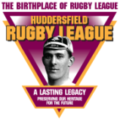 Theme 1

How Rugby Football Came to Huddersfield:
Developments in Rugby Football

Pupil Activity Sheet 2

1. Draw straight lines to join the name of the ancient people with the game that they played. (Source A, paragraph 3)

Chinese harpustum

Greeks tsu chu

Romans tlatchli

Aztecs episkyres

2. Read Source B. Look at the picture below.

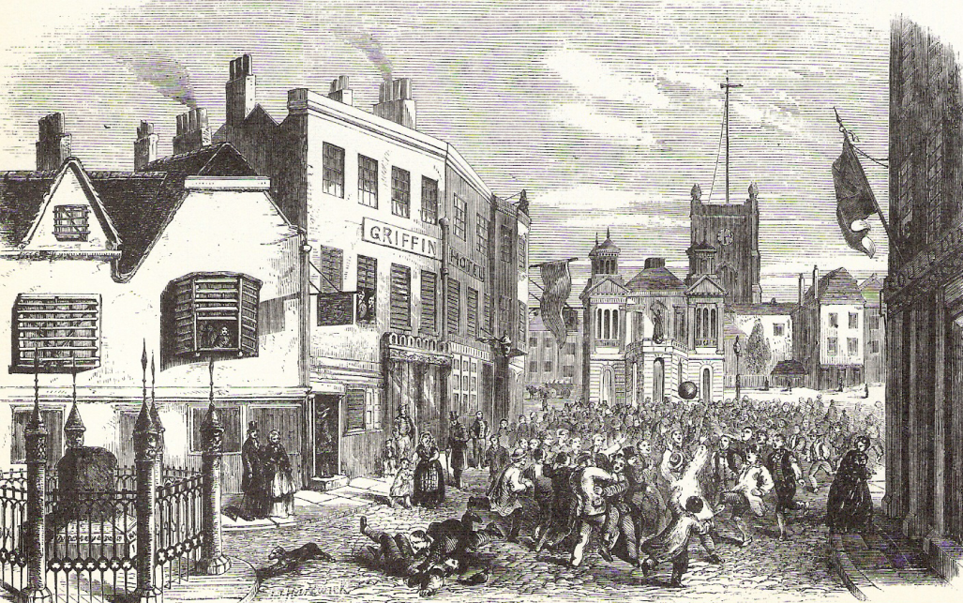

2a. What is the name of this game? _____________________________

2b. Tick the best two words to finish following sentence.

The people in the picture who are lying on the ground are...

i) asleep ii) laughing iii) injured iv) fighting
3a. Would you like to have played this game? (Source B) ___________

3b. Why do you think this?

______________________________________________________________

______________________________________________________________

______________________________________________________________

______________________________________________________________

4a. The following words are all used in Source B. Draw straight lines to join the words on the left to their meanings in Source B on the right.

resembled
(paragraph 2) laws or legal orders

highway
(paragraph 3) public road

decrees
(paragraph 4) looked similar to

4b. quibbling
(paragraph 5) din made by a crowd

hubbub
(paragraph 5) bruises

contusions
(paragraph 7) arguing

5. Which two sentences below explain the main ideas behind ‘Muscular Christianity’? (Source C, paragraph 2)

a) Playing football would help boys to have big muscles.

b) Playing fairly at sport would teach boys to be fair in life.

c) To be a Christian, boys must play football.

d) Playing to the rules of sport would teach boys to obey the law.

6. Why do teams need to play matches to a set of rules?
(Source D, paragraph 1)

a) physical fitness b) playfulness c) popularity d) fairness
7. Which sentence below explains why writing the rules of football (1863) and rugby (1871) made it easier for teams from different places to play matches? (Source D, paragraphs 1 and 4)

a) The rules made the players more skilful.

b) Teams could travel more easily from place to place.

c) Everyone understood what they could and could not do in the game.

d) Teams had competitions in which to play.

8. Which of the following phrases explains the main way that the club that is now Huddersfield Giants was formed? (Source E, paragraphs 2, 5 and 7)

a) Men from the same workplace b) Members of a local church

c) Men from a cricket or athletics club

9. Write the numbers 1 to 5 next to the following sentences to give the order of events that led to the club that is now Huddersfield Giants being formed. (Source E, paragraphs 3 and 4)

Young athletes set up their own gymnasium.

Professor John Le Blanc opened the Apollo Gymnasium.

Young athletes set up the Huddersfield Athletic Club.

The Volunteer Rifle Corps took over Huddersfield’s only theatre.

Professor John Le Blanc turned his gymnasium into a theatre.

10. The last paragraph of Source F states that matches in cup competitions had a ‘wider context’. What does this mean?

a) Matches in cup competitions counted towards something
bigger than just that game.

b) Matches in cup competitions attracted bigger crowds.

c) Matches in cup competitions made the clubs more money.

d) Matches in cup competitions were more exciting.

11. Why do you think the cup competition for Huddersfield’s amateur clubs was called the ‘Holliday Cup’? (Source F, paragraph 3)

______________________________________________________________

______________________________________________________________
12. Tick the phrase that completes the following sentence.
(Source G, paragraphs 1 to 3)

Leagues started because...

a) all matches were exciting.

b) clubs wanted more matches that counted towards a competition.

c) lots of cup competitions had started.

13. In which three sports were leagues set up between 1888 and 1896? (Source G, paragraphs 4 to 6)

_________________ _________________ _________________

14. Which sport was ‘born’ in 1895? (Source H, paragraph 3)

a) athletics b) cricket c) football

d) rugby league e) rugby union

15. In 1895 22 clubs, including Huddersfield, broke away from the Rugby Football Union to set up the Northern Union. Why did they do this?
(Source H, paragraphs 2 and 3)

a) They wanted to carry on playing in a league.

b) They wanted to run their own cup competition.

c) They wanted to make up the wages their players lost
when they left work early to travel to their match.

d) They did not want to play teams from the south of England.

16. Either:
Design a poster to advertise a mob football match. (Source B)

Remember to include:
- the date and time
- the venue – place – where it will be held
- the teams
- words that persuade people to play.

or:
Imagine that you have just played in a mob football match and write a descriptive account of the game.

